UNITED4Surveillance

Grant agreement number: 101102070

Union and National Capacity Building

4 IntegraTED Surveillance

NATIONAL DISSEMINATION PLAN

ESTONIA

Milestone MS19

Dissemination level: Sensitive

Version Number V1.4

May 2024

Work Package 6: Dissemination

Work Package Leader: Rijksinstituut voor Volksgezondheid en Milieu (RIVM), Netherlands

Co-leader: Nacionalinis visuomenes sveikatos centras prie Sveikatos apsaugos ministerijos (NVSC), Lithuania

**Document History**

|  |  |  |  |
| --- | --- | --- | --- |
| **Version** | **Date** | **Partners** | **Description** |
| V1.0 | 2023-05-12 | NVSC | First draft of National dissemination plan template |
| V1.1 | 2023-05-17 | RIVM | Description, comments and suggestions from RIVM |
| V1.2 | 2023-05-19 | NVSC | Corrections from NVSC |
| V1.3 | 2023-05-24 | RIVM | Additional comments and suggestions from RIVM |
| V1.4 | 2023-05-24 | NVSC | Final version from NVSC |
| V1.5 |  |  |  |
| V1.6 |  |  |  |
| V1.7 |  |  |  |

**Content**

1 INTRODUCTION 5

2.1 Purpose of the NATIONAL dissemination plan 5

2.2 Objective 5

2.3 Outline of the dissemination plan 5

3 Stakeholders analysis 5

4 Dissemination methods and tools 7

4.1 CONFERENCES-Workshops-meetings 7

4.2 PRESS REalise 7

4.3 Scientific Journal 8

4.4 Annual report 9

4.5 WEBPORTAL 9

4.6 Other means of national dissemination activities 10

5 MONITORING of national Dissemination activities 10

**Tables**

Table 1: Table 1. List of conferences-meetings-workshops……………………………………………………………………..7

Table 2. List of press realises……………………………………………………………………………………………………………….8

Table 3. List of scientific journals………………………………………………………………………………………………………….8

Table 4. List of annual reports……………………………………………………………………………………………………………..9

Table 5. List of websites……………………………………………………………………………………………………………………..9

Table 6. Reporting periodicity and deadlines…………………………………………………………………………………………10

**Figures**

Figure 1: Levels of interest to the Project 6

**Annexes**

Annex 1: Template for collecting contact details of stakeholders………………………………………………………………12

Annex 2: Dissemination monitoring form template………………………………………………………………………………..12

# INTRODUCTION

## PurpOse of the NATIONAL dissemination plan

This document contains the National dissemination plan of the UNITED4Surveillance (Work Package 6, Milestone 19).

Dissemination is the process of making activities and achieved results of the UNITED4Surveillance available to the stakeholders and other interested audiences. The National dissemination plan will help to plan the activities related to the dissemination of the UNITED4Surveillance outcomes with stakeholders, concerned institutions, organizations and etc. in your country.

National dissemination plan will be updated depending on the country's needs and activities.

## Objective

The main objectives of the National dissemination plan are:

* Raise awareness about UNITED4Surveillance, it’s activities and outcomes at national level.
* Communicate the UNITED4Surveillance progress in a clear way depending on the audience and thereby ensure broad stakeholder’s and target groups engagement at different levels at national level.
* Ensure UNITED4Surveillance sustainability through the Project ‘s outcomes at national level.

## Outline of the dissemination plan

National dissemination plan includes information about:

* Who is the key audience and target groups and they need assessment.
* What kind of information and activities will be disseminated.
* Want kind of dissemination methods will be used.
* Periodicity of the reporting of national dissemination activities.

# Stakeholders analysis

A stakeholder is a person, group or organization who have an interest in or will be affected by the UNITED4Surveillance outcomes.

One of the most important tasks is the identification of national stakeholders and their needs as well as settings of their influence and interest in the UNITED4Surveillance

Four different levels of stakeholders have to be identified:

* **High interest/high influence.** Any stakeholder in this group is a priority and need to be fully informed, consulted and engaged. These stakeholders have an immediate interest, benefit and influence to the UNITED4Surveillance.
* **High interest/low influence.** Stakeholders in this group are interested so there is need to keep them in touch but don’t expect them to be fully involved.
* **Low interest/high influence.** Stakeholders in this group may be useful to the Project certain activities so they have to be informed enough so they can help if needed.
* **Low interest/low influence.** Stakeholders in this group may be wished to be informed with occasional briefings or via social media/website.

The level of interest and the level of influence are demonstrated in Figure 1. The methods of communication with stakeholders will depend on which group he will be assigned to.

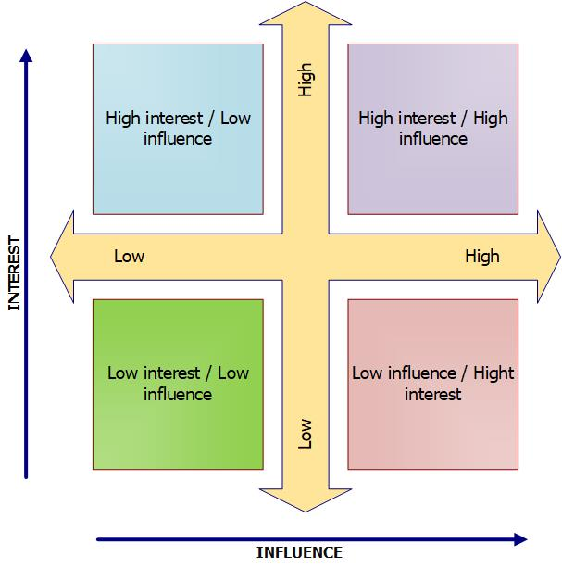

Figure 1: Levels of interest to the Project

The UNITED4Surveillance targets the following groups - personnel working at countries national/local authorities responsible for communicable diseases management and implementation of one health approach (health, including public health) institutions, laboratories, veterinary services, environmental agencies and etc.).

Please identify the stakeholders of the UNITED4Surveillance outcomes and activities in your country by completing the National stakeholder list presented in Annex 1.

# Dissemination methods and tools

## CONFERENCES-Workshops-meetings

One of the most important dissemination parts is the dissemination that will be achieved through presentations to national conferences, workshops and other collaborative events, including the meetings with policy and decision makers. During these events, UNITED4Surveillance partners will present the ongoing research on the field of reference of the Project.

Please list *(Table 1)* the any conferences, workshops, meetings you are planning to organize or participate in your country in the next three years (2023-2025) in which the UNITED4Surveillance activities and outcomes could be presented.

**Table 1. List of conferences-meetings-workshops**

|  |  |  |  |  |
| --- | --- | --- | --- | --- |
| No | Conference-workshop-meeting name | Preliminary date | Location | Organizer |
| 1 | Annual Conference of the Health Board (HB) CD Epidemiology Department | May 2023 | Tallinn | Health Board |
| 2 | Annual Conference of the Health Board (HB) CD Epidemiology Department | November 2024 | Tallinn | Health Board |

## PRESS RElEase

Summaries of newsworthy events or results achieved by the UNITED4Surveillance partners in the country will form the content of press releases. Press releases/reports are used to communicate information proactively to the media and from there to the wider public, from which the elements that are considered of interest to the public are selected.

Press releases are an important tool that can be used throughout the UNITED4Surveillance. An approach that has proved successful when using press releases is for project partners to issue press releases simultaneously in their countries, giving journalists local contact points in order to follow-up in their own languages.

Please list (Table 2) dates and occasions where there is a possibility for the UNITED4Surveillance activities to be announced through a press release.

**Table 2. List of press releases**

|  |  |  |  |
| --- | --- | --- | --- |
| No | Press releases | Preliminary date | Organizer |
| 1 | Main results achieved by the UNITED4Surveillance project | 2025 | Health Board |

## Scientific Journal

Targeted publications refer to Journals, referred conferences and scientific surveys. Partners are asked to identify national scientific journals where the results and outcomes of the UNITED4Surveillance could be potentially published.

Please list (Table 3) any scientific journals published in your country either by your authority or by others where articles about the UNITED4Surveillance activities could be published.

**Table 3. List of scientific journals**

|  |  |  |  |  |  |
| --- | --- | --- | --- | --- | --- |
| No | Scientific journal | Preliminary name of the survey | Preliminary date | The author of the survey | The publisher |
| 1 |  |  |  |  |  |

## Annual report

Please list (Table 4) any annual report published in your country either by your authority or by others where articles about the UNITED4Surveillance progress and outcomes could be published.

**Table 4. List of annual reports**

|  |  |  |  |
| --- | --- | --- | --- |
| No | Annual report | Preliminary date | Organizer |
| 1 | Monthly EstEpiReport | IVQ 2024 | Health Board |
| 2 | Annual report on CD | II 2025 | Health Board |

## WEBPORTAL

The website is especially important in promoting the UNITED4Surveillance and posting results and dissemination material.

Please identify (Table 5) the links of the websites where the activities and outcomes of the UNITED4Surveillance could be published.

**Table 5. List of websites**

|  |  |  |
| --- | --- | --- |
| No | URL of the website | Holder |
| 1 | [www.terviseamet.ee](http://www.terviseamet.ee) | Health Board |

## Other means of national dissemination activities

Please list any other national dissemination activities you are planning to organize to disseminate the UNITED4Surveillance activities and outcomes.

1. Meetings with One Health partners (Agriculture and Food Board, LABRIS and Ministry of Rural Affairs)
2. Workshops/meetings of CD Epidemiological Department with Regional Departments of Health Board
3. Workshops/meetings and sharing of plans/establishing good balance between two projects: the consortium EU4H-PJG (EU4H Project Grants) and OH4Surveillance and project 101102070 — UNITED4Surveillance

# Meetings with Regional departments of HealthBoard MONITORING of national Dissemination activities

All national dissemination activities should be reported periodically to the UNITED4Surveillance WP6 “Dissemination” leaders by completing the Dissemination Monitoring Form presented in the Annex 2 via TEAMS.

Reporting periodicity and deadlines are presented in Table 6.

|  |  |
| --- | --- |
| Reporting period  (M - month) | Deadline |
| M1-M6 | 15th of July, 2023 |
| M7-M9 | 15th of October, 2023 |
| M10-M12 | 15th of January, 2024 |
| M13-M15 | 15th of April, 2024 |
| M16-M18 | 15th of July, 2024 |
| M19-M21 | 15th of October, 2024 |
| M22-M24 | 15th of January, 2025 |
| M25-M27 | 15th of April, 2025 |
| M28-M30 | 15th of July, 2025 |
| M31-M33 | 15th of October, 2025 |
| M34-M36 | 15 of January, 2026 |

**Table 6. Reporting periodicity and deadlines**

References

1. European Commission. Consumers, Health, Agriculture and Food Executive Agency. Grant agreement Number – 101102070 — UNITED4Surveillance, 2022.
2. European Commission. Executive Agency for Health and Consumers. Project Management in Public Health in Europe. European Union, 2011.
3. Eastsuffolk council. (n.d.) Guide to doing a Stakeholder analysis. Available from: https://www.eastsuffolk.gov.uk/assets/Community/community-led-planning/Guide-to-doing-a-stakeholder-analysis.pdf
4. EU HEALTHY GATEWAYS Joint Action, Dissemination Plan. November 2018.
5. EU UNITED4Surveillance Joint Action, Dissemination Plan. February 2023.

Annexes

Annex 1: Template for collecting contact details of stakeholders



Annex 2: Dissemination report template

